User’s Manual
Hyper-V VIM tool (HVIM) User’s Manual
Version 1.7
May 1, 2018

Version History
Ver | Date | Author | Details
1.0 | 12/09/2017 | Dudi.Avrahamov@verint.com | First revision.
1.1 | 10/12/2017 | Dudi.Avrahamov@verint.com | After adding cluster support.
1.2 | 12/12/2017 | Dudi.Avrahamov@verint.com | After adding KBs installation on Hyper-V hosts.
1.3 | 18/12/2017 | Dudi.Avrahamov@verint.com | Changes after review by Michal and Lior.
1.4 | 24/12/2017 | Dudi.Avrahamov@verint.com | Added Management Machine Preparation section.
1.5 | 17/1/2018 | Dudi.Avrahamov@verint.com | Added support for SDC.
1.6 | 1/2/2018 | Dudi.Avrahamov@verint.com | Added requirement for Allow Fresh Credentials with NTLM-only Server Authentication needed by CredSSP.
1.7 | 1/5/2018 | Dudi.Avrahamov@verint.com | Move Microsoft-Hyper-V and RSAT to optional.
1.8 | 21/11/2018 | Dudi.Avrahamov@verint.com | Added support for Hyper-V 2016  Created Windows Server 2016 template
1.9 | 27/3/2019 | Dudi.Avrahamov@verint.com

Abstract: Hyper-V VIM tool (HVIM) User’s Manual

Table of Contents
1. Introduction 4
1.1. Scope 4
1.2. References 4
1.3. Glossary 4
1.4. Prerequisites 5
1.5. Management Machine Preparation 5
1.6. Hyper-V Hosts preparation 6
1.7. HVIM deployment tool 7
1.8. Clear the Environment 8
1.9. HVIM Validation Report Tool 8
1.10. Logging 9
2. HVIM Excel file description 10
2.1. Environment 10
2.2. Hosts 11
2.3. VMs 11
2.4. HostNetwork 12
2.5. VMNetwork 12
2.6. HostDisks 13
2.7. VMDisks 13
3. Troubleshooting 14
4. Creating a Windows Template 16

1 Introduction

2 Scope
This User’s Manual covers the HVIM tools usage.
The HVIM deployment tool is used in order to create a Hyper-V virtualized environment.
This User’s Manual describes each of the tools and how to use them.

The HVIM currently supports the following operating systems for VM deployment:
- Windows server 2012 R2
- Windows server 2016
- Ubuntu 14.04

3 References
[1]

4 Glossary

Term | Meaning
SR | Server Readiness Tool (Master Installer)
HVIM | Hyper-V Virtual Infrastructure Management

5 Prerequisites
- Hyper-V hosts installed with Hyper-V Server 2016.
- Management machine installed with Windows 10.

6 Management Machine Preparation
Note: The HVIM tools currently run on windows 10 OS only!
In order to prepare the management machine to run HVIM, the following steps should be performed:
- Open PowerShell and set execution policy to Remote Signed by runing the following command: Set-ExecutionPolicy -ExecutionPolicy RemoteSigned
- Run winrm quickconfig
- Use gpedit.msc and look at the following policy: Computer Configuration ->
Administrative Templates -> System -> Credentials Delegation -> Allow Fresh Credentials with NTLM-only Server Authentication. Verify that it is enabled and configured with an SPN as wsman/*.
- Copy the Hyper-V VM templates to a location of your choice, on your your management machine.
- Copy the MPS Kit to a location of your choice, on your management machine.
- Copy the HVIM directory to a location on choice, on your management machine.
- Open the HVIM Excel file and go to the Environment tab (sheet).
- Edit the following parameters to point to the file paths on your management machine:
- TemplateSourcePath – The location where you the VM templates reside.
- MPSKitPath – The location where the MPS Kit reside.

Optional Installations:
- Open PowerShell and install Hyper-V tools (including Hyper-V Manager) by runing the following command:
Enable-WindowsOptionalFeature –Online -FeatureName Microsoft-Hyper-V –All
- Install Remote Server Administration Tools (RSAT)
Download and install WindowsTH-RSAT_WS2016-x64.msu. It resides in the install folder.

7 Hyper-V Hosts preparation
In order to prepare the Hyper-V hosts for deployment, the PrepareHost.ps1 script file should be executed on each of the hosts using PowerShell.
This file resides inside an ISO file (HostPreparation.iso), that resides here, and can be mounted to the host by using KVM (e.g. iDRAC).
In order to run the script it, open a PowerShell window on the host and execute the PrepareHost.ps1 script.
When running the script you will see a similar window like this:
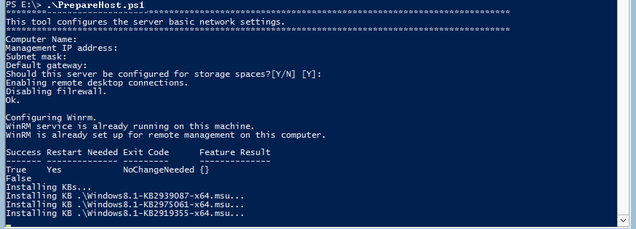
This script performs the following tasks in this order:
- Set the Hyper-V host name (optional)
- Configure management IP settings of NIC1 (optional)
- Enable remote desktop connections.
- Disable the FW
- Configure Winrm
- Configure Multipath IO
- Installs the relevant KBs for the host.

8 HVIM deployment tool
In order to run the tool you need to execute the DeployAll.bat batch file that resides in the root folder.
This batch file runs the main tool’s PowerShell script (deploy.ps1) that performs the following deployment tasks:
- Configure the Hyper-V hosts (Teaming, vSwitches, etc), hard-disk partitions, Copy Hyper-V templates, etc.)
- Create a VM for the MPS, run the SR on it in order to make it a DC and then installs all the other MPS components.
- Join the Hyper-V hosts to the domain.
- In case of a cluster environment:
  - Creates a cluster and adds the Hyper-V hosts as nodes to it.
  - In case storage type is “Storage Spaces” create a shared Storage Pool.
  - Create the Cluster Quorum virtual disk and add it to the cluster.
  - Create the Cluster Sahred Storage (CSV) virtual disk and add it to the cluster.
- Deploy the Hyper-V guests (VMs) on the Hyper-V hosts and join them to the domain (in case of a cluster environment it also adds the VMs to the cluster as roles).
All the configuration data is taken from the input HVIM Excel file. A sample Excel file resides under the ‘config’ directory.
When you run the tool, the first input it asks for is the path\name of the Excel file.
The excel file consists of several sheets. Their description can be found in section 2.
The deploy.bat batch file should be run as administrator.
When running the tool you will see a similar window to this:
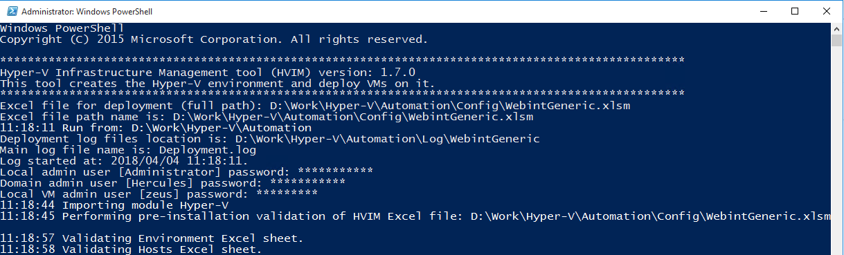
The PowerShell window appears and asked for the following parameters:
- The full path to the HVIM Excel file.
- Local admin “Administrator” password (Rel7…)
- Domain admin “Hercules” password (Rel7…)
- Local VM admin “zeus” password (Nine1…)
Insert the full path for the HVIM Excel file and the required passwords. Note that the password for “zeus” is different from the other passwords.
These parameters will be saved in the LastSession.xml file for next run.
When running the tool again, you can simply press enter on each question.

9 Clear the Environment
In order to clear the environment you need to run the ClearEnvironment.bat batch file.
You can simply press enter on each question you are asked.
When running the tool you will see a similar window to this:
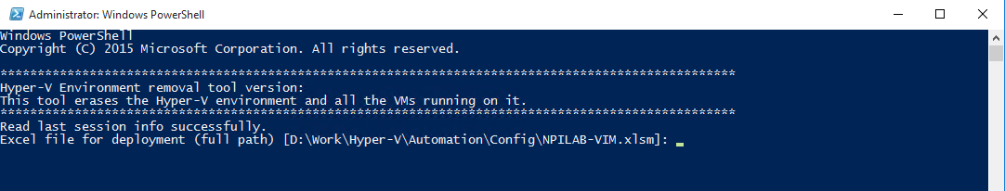
This batch file runs powershell script (ClearEnvironment.ps1) that performs the following tasks:
- In case of clustered environment:
  - Remove the VM’s roles from the cluster.
  - Remove cluster quorum.
  - Destroy the cluster.
- Remove Hyper-V hosts from the domain.
- Remove disk partitions created by the HVIM deployment tool, from the hosts.
- Clear teamings, vSwitches and virtual network adapters.
- In case of clustered environment:
  - Remove shared pool virtual hard disks.
  - Remove shared pool.

10 HVIM Validation Report Tool
The HVIM validation report tool is a post installation tool. You need to run it after the HVIM deployment tool and all manual installations and configurations are finished. This tool queries the system in order to check if it is configured correctly. It creates a report in HTML format (HVIMValidationReport.htm). The HTML file can be found in the log directory.
In order to run the tool, run the batch file named ValidationReport.bat.
You can simply press enter on each question you are asked.
The following screenshot is an example report:
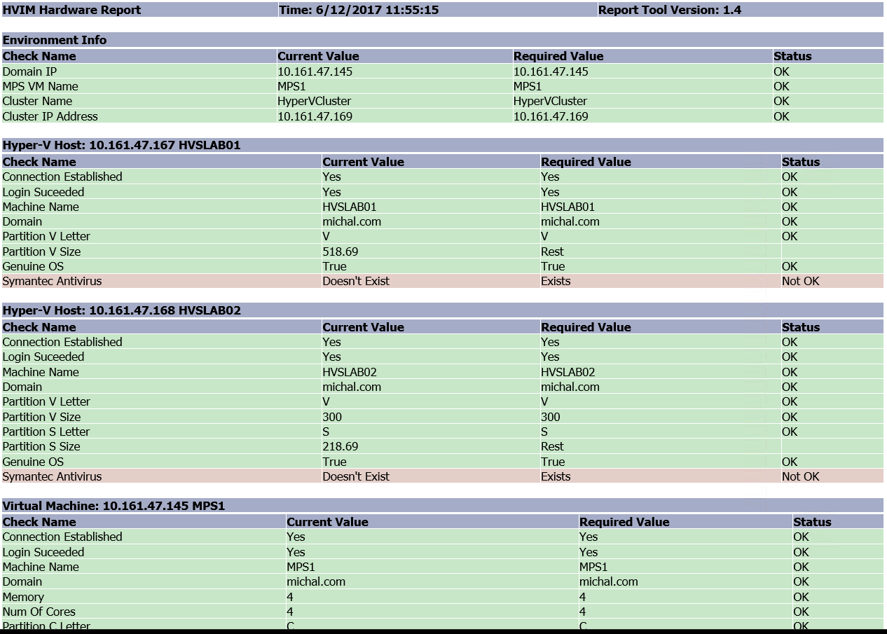

11 Logging
For each HVIM Excel file a separate log sub folder, will be created under the ‘log’ folder.
The name of the sub folder will be the name of the Excel file.
For the the deployment log look for the Deployment.log file.
For the the clear environment log look for the ClearEnvironment.log file.
In case of using jobs (configured in Excel file) for deployment in parallel then a separate log file will be created for each Hyper-V host. The name of the file is the name of the host.

12 HVIM Excel file description

13 Environment
This sheet contains all the environment variables as name/value pairs. These variables are used all over the HVIM tool.
Variable Name | Description
Domain_Name | The domain name
NetBios_Name | The domain NetBios name (for easy logon)
Domain_IP | The IP address of the primary Domain Controller (MPS)
MPS_VM_Name | The MPS computer name
SDC_Domain_IP | The IP address of the secondary Domain Controller (SDC)
SDC_VM_Name | The SDC computer name
TemplateSourcePath | The path where the VHDX templates should be copied from to the Hyper-V hosts
TemplatePathOnServer | The path where the VHDX templates will be copied to, on the Hyper-V host
MPSKitPath | The path (network or local) to where to copy the MPS kit (SR components) from
MPSComponentType | You need to select the type of MPS components to be installed (select none in case just DC is needed).
UseJobs | Internal use: Controls whether the hosts deployment will be done in parallel by using jobs or not
Environment | Standalone or Cluster
Cluster_Name | Cluster name (e.g. HyperVCluster)
Storage_Type | The storage type: Storage Spaces or Central Storage.
Cluster_IP_Adress | The Cluster IP address
Live_Migration_Net_Adapter_IP_Prefix | 192.168.1.x where x is the last octet of the management network IP address.
Live_Migration_Network_Sunet_Mask | Subnet Mask (e.g. 255.255.255.0)
Live_Migration_Network_VLAN | The network VLAN ID. For none type "0"
Heartbit_Net_Adapter_IP_Prefix | 192.168.2.x where x is the last octet of the management network IP address
Heartbit_Network_Sunet_Mask | Subnet Mask (e.g. 255.255.255.0)
Heartbit_Network_VLAN | The network VLAN ID. For none type "0"

14 Hosts
Every row in this sheet contains the basic Hyper-V host configuration details.
Field Name | Description
HostIP | The Hyper-V host management IP.
Hostname(NetBIOS) | The host name of the Hyper-V host.
SubnetMask | The subnet mask of the management network adapter.
DefaultGateway | The default gateway of the management network adapter.
SecondaryDNS | The secondary DNS if exists.
Failover | For future use by the cluster.
JoinToDomain | If set to Yes, the host will be joined to the domain, otherwise it will be not.
Enabled | If set to Yes, the host will be configured, otherwise it will not.
Role | Describes the role of the Hyper-V host (free text).

15 VMs
Every row in this sheet contains VM configuration details that is used in order to create this VM.
Field Name | Description
ComputerName | The VM computer host name that will be created.
HostIP | The Hyper-V host IP address that this VM will be deployed on.
Volume | The volume where to locate the VM (VHDX, checkpoints, etc.) files.
OSProfile | The type of OS to be deployed. Currently supported OSs are Windows server 2012 R2, Windows server 2016 and Ubuntu 14.04.
Cores | The number of cores that will be set on the VM.
Memory | The amount of memory in GB that will be set on the V.
PrimaryIP | The VM’s primary IP address.
Subnet | The VM’s network adapter subnet mask.
DefaultGateway | The VM’s network adapter default gateway.
SecondaryDNS | The VM’s network adapter secondary DNS.
vSwitchName | The switch name that the VM’s network adapter will be attached to.
ComputerName | The VM computer host name that will be created.
JoinToDomain | If set to Yes, the VM will be joined to the domain, otherwise it will be not.
OrganizationalUnit | The organizational unit (OU) that the VM should be attached to.
HostTimeSync | If set to Yes, the VM guest time will be synced with the VM host, otherwise it will not.
Enabled | If set to Yes, the VM will be created and configured, otherwise it will be ignored.

16 HostNetwork
Every row in this sheet configures the specified Hyper-V host network, by creating a teaming from the specified NICs, a vSwitch and a virtual network adapter (in case the vSwitch is intended for management).
Field Name | Description
Hostname(NetBIOS) | The host name of the Hyper-V host to configure.
TeamingName | The network teaming name that will be created
TeamingNICs | A comma separate two elements list of NICs that the teaming will be created with (e.g. NIC1,NIC2). In case there is no option to create a teaming of two NICs, you can specify a single NIC by doubling it. For example NIC1,NIC1. You can find the NICs names by running the following PowerShell command on the host: “Get-NetAdapter” under “name” column.
vSwitchName | The name of the virtual switch that will be created and attached to the teaming.
IsForManagement | If set to ‘Yes’ it means that an extra network adapter will be created and configured with the management IP specified in the hosts sheet.

17 VMNetwork
Every row in this sheet creates an additional virtual network adapter and adds it to the specified VM.
Field Name | Description
ComputerName | The VM OS host name (the same as the VM name).
IP | The network adapter’s IP address
Subnet | The network adapter’s subnet mask.
VLANID | The VLAN ID. Can be left empty if VLAN is not in use.
vSwitchName | The vSwitch name the created network adapter should be connected to.

18 HostDisks
Every row in this sheet contains the details for a partition (volume) that will be created on a disk installed on a Hyper-V host:
Field Name | Description
Hostname(NetBIOS) | Identifies the host name of the Hyper-V host.
DiskNum | The disk number on which the partition will be created. You can find the DiskNum by running the following PowerShell command on the host: “Get-PhysicalDisk | select FriendlyName, Size, DeviceId” under “DeviceID” column
Size(GB) | The size in GB of the partition to be created or “Rest” for using entire available space.
DriveLetter | The drive letter to be attached to the partition created.
IsSystemDisk | If set to ‘Yes’ this means the disk this volume is supposed to be created on, contains the OS partition. If set to ‘No’, then all existing partitions will be removed from the disk, before the creation of the new volume.

19 VMDisks
Every row in this sheet contains the details for the virtual disk (VHDX) that will be attached to the specified VM and the volume that will be created on this disk:
Field Name | Description
ComputerName | Identifies the VM by its computer name (hostname).
DriveLetter | The drive letter to be attached to the partition created on the disk.
Capacity | The capacity of the virtual disk in GB.
Label | The label to be attached to the partition created on the disk.

Notes:
- You don’t have to specify details for the virtual disk containing C: volume, since it is part of the VM template. However in case you need a bigger C: volume size than 42G, then you can add a row to this table. In this case the VHDX and the C: partition will be enlarged to the specified size.
- The name of the VHDX file will be the name of the VM concatenated with the volume drive letter. E.g. VM1_C for VHDX containing drive C:.
- For MPS the following disks should be defined:
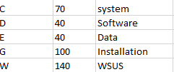

20 Troubleshooting
Problem | Possible Solutions
Can’t connect to Hyper-V host using Hyper-V manager. | - Verify there is no DNS suffix defined for any network adapter on the management machine.  - Verify that firewall on management machine is totally disabled.  - Verify that firewall on Hyper-V host is totally disabled.  - Insert the name of the Hyper-V host machine to the client hosts file with its IP address.  - Verify that the user credentials are the same in management machine and in Hyper-V host.
Can’t ping Hyper-V host from management machine | - Verify that firewall on management machine is totally disabled.  - Verify that firewall on Hyper-V host is totally disabled.  - Verify the default gateway is configured on the management network card.
The HVIM deploy tool fails after deploying the MPS | - Connect to the MPS machine and run the Hyper-V manager.  - Check the log on screen or on file system and see where it failed. In most cases it has failed on a specific VM.  - Connect to the Hyper-V host that this VM reside and remove it. You should remove the VM files from the host file system as well (or form the shared storage in case of a clustered environment).  - Open the VIM Excel file and disable the MPS deployment on the VMs tab.  - Change the wrong definition (e.g. wrong vSwitch name or memory size is too big).  - Run the HVIM tool again.
When trying to start a VM the following error is displayed: “could not initialize machine remoting system. Error: 'Element not found.'(0x80070490)” | This problem occurs because the Hyper-V VMMS malfunction. In order to solve it, you need to restart the Hyper-V VMMS or the Hyper-V host.
Can’t join an Hyper-V host to the domain | Verify that the host IP can be pinged from the MPS virtual machine. In case they are in different subnets, it is most likely that the switch is not configured to let the two subnets to be connected.
Get the following error: The WinRM client cannot process the request. A computer policy does not allow the delegation of the user credentials to the target computer because the computer is not trusted. | Use gpedit.msc and look at the following policy: Computer Configuration ->Administrative Templates -> System -> Credentials Delegation -> Allow Fresh Credentials with NTLM-only Server Authentication. Verify that it is enabled and configured with an SPN as wsman/*.
Network connectivity issues. | - Verify there is no MAC addreses conflicts, by verifying all vNICs MAC addreses on all Hyper-V hosts are different.  - Verify all KBs are installed.  - Verify there is no IP addresses conflict.

21 Creating a Windows Template
- Use the Hyper-V Manager to create a VM.
- Create a C drive with size of 50GB and Install Windows on it.
- Set administrator password as Rel7….
- Change UAC to lowest.
- Disable the Windows Firewall completely.
- Enable remote desktop connection from any RDP version.
- Copy Unattended.xml from earlier version, change its product key to the new one and verify it works.
- Run Sysprep with generalize and shutdown options.

